“**Capstone Project `RoboFone`”** : As the name suggests this project has to do something with a robot and a smartphone and this why we chose that name.

Project’s main aim was to use capabilities of a phone and use it in different real world important applications.

a) **Use in Military Operations**:- Like everyone I like playing first person shooter genre games like Battlefield, Call of Duty etc. Playing them you feel it is easy to wipe out whole bunch of enemies where you are the only one standing against all of them. So you use stealth, direct approach, bombs, different guns as a part of strategy while you know there will be a second chance from previously saved checkpoint from where you can carry off again. Obviously same is not the case with military personnel as they only get 1 chance 1 strategy and there is always some valuable irrecoverable loss of life.  
So for this case this idea of RoboFone may help to provide a better way giving same comfort level of games and no life loss.  
Military can send this robot(bulletproof coated) to the war field while the military men just sit at their safe places where they will get a live video feed from the camera on robot(or phone’s Camera) to their personal pc’s, laptop or even mobile phones. After looking at the video feed they can control the robot movements and gun firing by using our software just like Call of Duty Game. You will see live feed, laser aim, control movements, can change the type of gun(we have only used one), effects like vibration on hit or on being hit(on android phone only), can be used in both manual (where user is only authorized to control) and in auto mode(using FaceDetection and Artificial Intelligence techniques) which takes us 1 step ahead of simply playing games.

Also we incorporated Face Detection and Face Recognition which can be used in the scenario where there are some innocents along with terrorists so it will first detect all the faces in the scene and then matches them all with given terrorist photo(server side), so innocents are not harmed while firing. Also some real time things can be thought of where a man with gun or a mask will be recognized using Computer Vision techniques but these things are still debatable and can be easily incorporated when needed.

b) **In Gaming**:- Normally you have seen people play games on their phone by tilting phone using phone’s

inbuilt sensor while one play desktop games using keyboard or gamepad. But there are some car racing games etc which will be more enjoyable using the same sensor technology.

There is a separate app for this where one can play Desktop Game controlled by phone's sensor wirelessly.

Or it has another option where you can use it as a wireless gamepad like XBOX wireless gamepad and can play any game and configure your controls from the desktop software.

c) **Some other important applications:-**  
**In AC Ducts**:- Normally AC Ducts are too small for human to go and clean. One can use this robot and

from the live feed control the vacuum cleaner and clean them. Obviously size of the robot can be reduced to what is the needed for this specific purpose.

**In Fire Extenguishing**:- In some places where fire fighters can’t go they can send this robot after coating it with some protective sheath and then controlling the mechanical action of pump or fire extinguisher by remaining at safe place.

**Finding Devices**:- One can put a small Bluetooth module in your purse etc. and then if you can’t find it in your home you can just press the button corresponding to purse on your app and it will sound alarm so you can find it. Also an optional gps module is there for getting co-ordinates.

d) **Personalized Cloud** :- This, for me finds many applications in day to day life of an individual.  
Lets say for instance I am downloading some heavy data on my pc and I am always eager to check the downloading percentage, so I stay close to my pc for hours. Now using this app and making a pc type account for your pc on the app, you can personally make some scripts for some specifc purpose and can run this script from anywhere using your account on mobile which will fetch you the download percentage.  
Similarly there is much more to this. You can explore your pc files from your mobile and then fetch some files, photos directly from there to your mobile or you can send some files and pc will do some processing on them according to your script and return the processed files back to your mobile.

Below are the few pics related to project

  
Robot in real world  
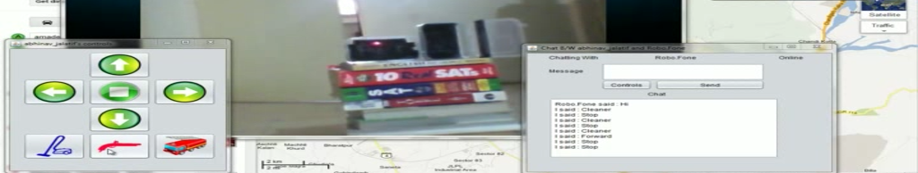  
Robot controlled from feed and our software.  
 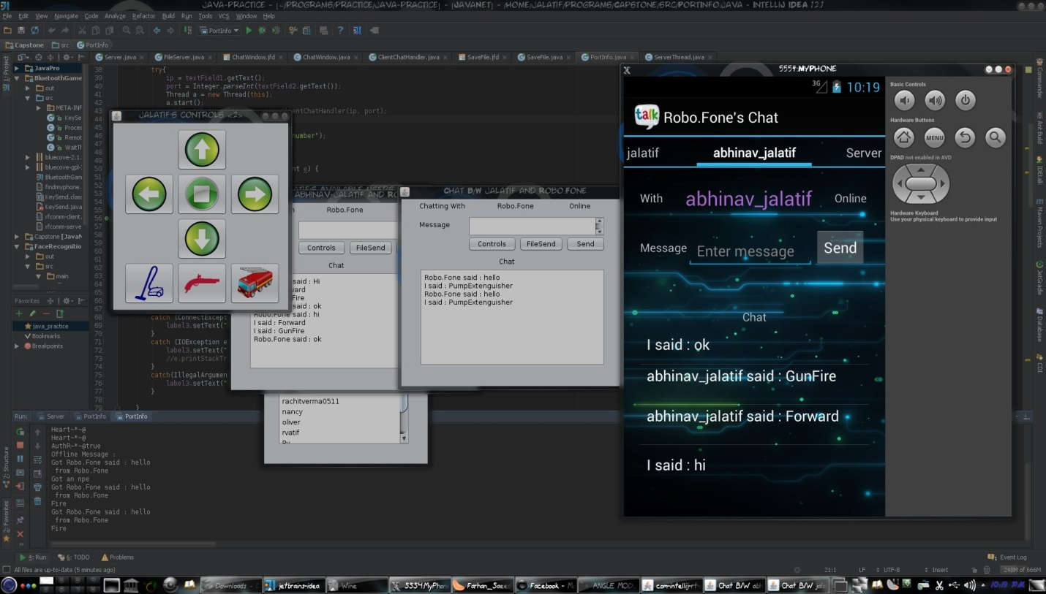  
Control from both PC(Linux, Windows or Mac) and Android(Shown in Emulator).

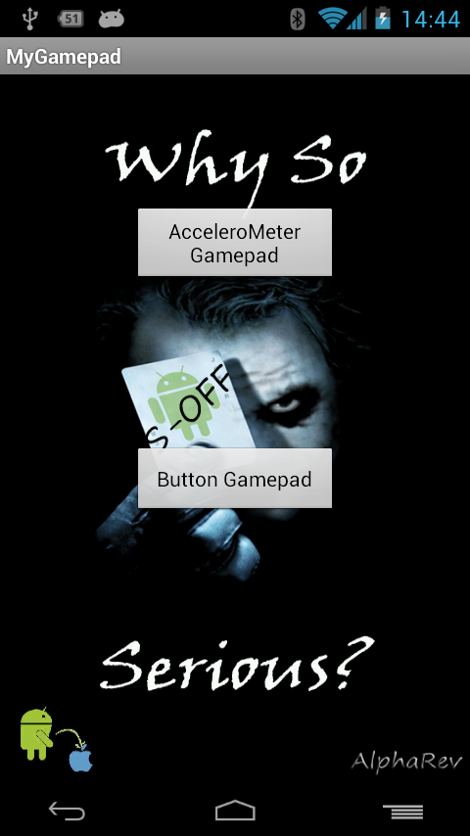

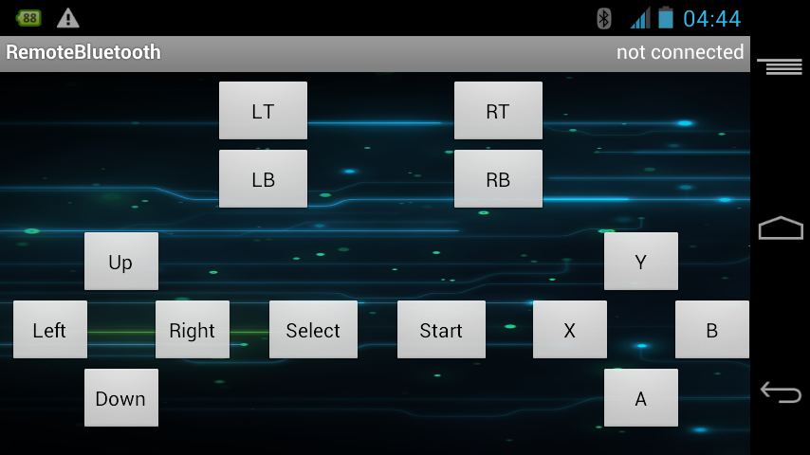  
Button Gamepad for wirelessly playing different pc games.

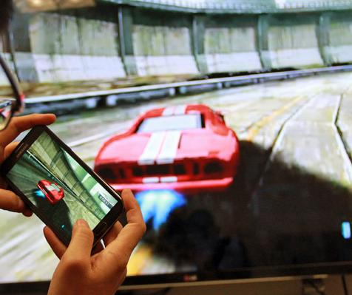  
Pc game nfs controlled from Android mobile

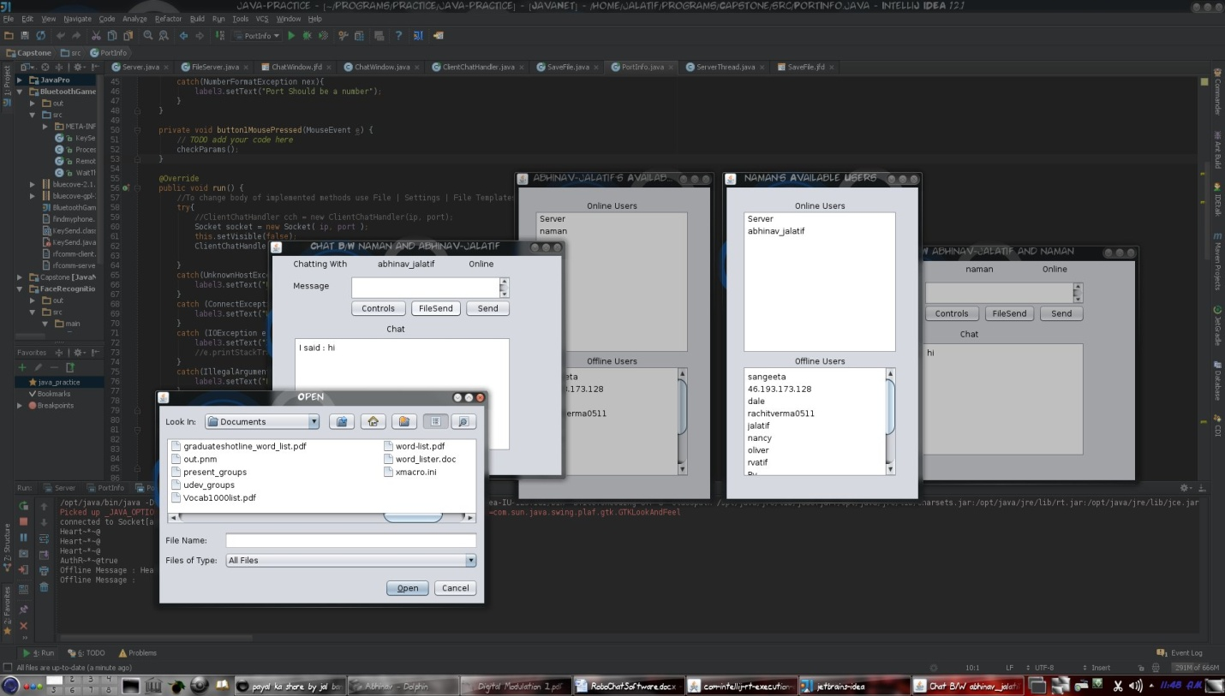  
File sharing after processing it from the server

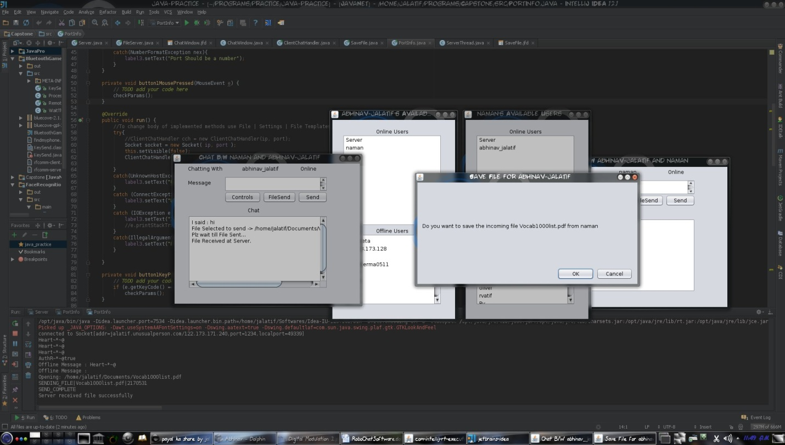

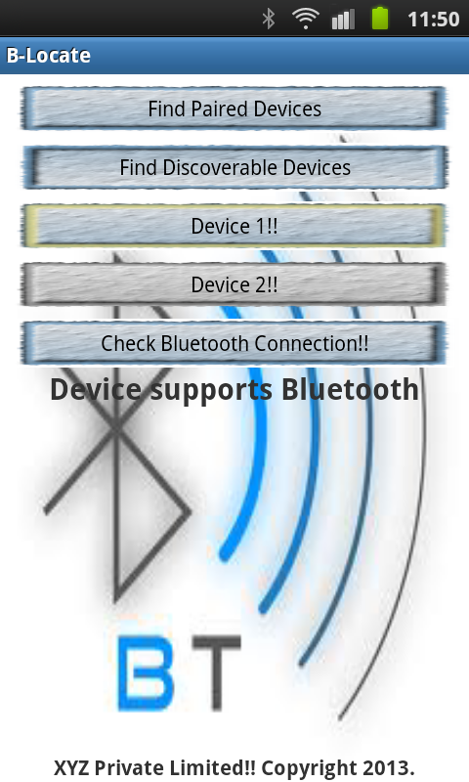  
For locating devices

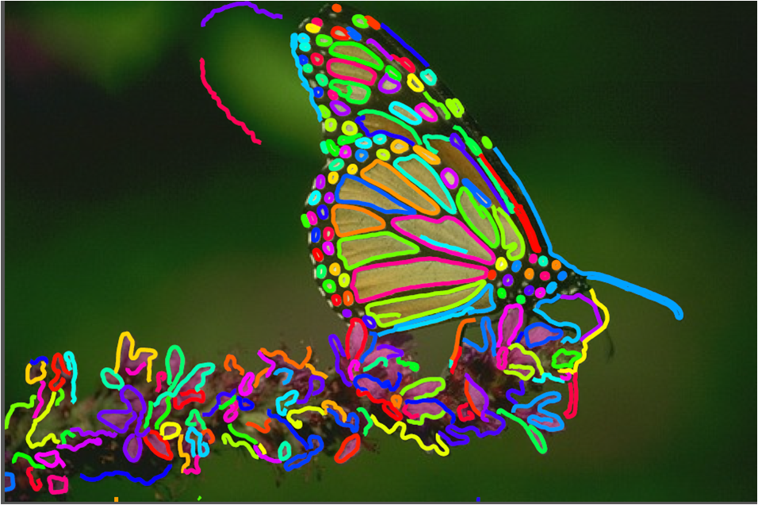  
Object type and shape detection  
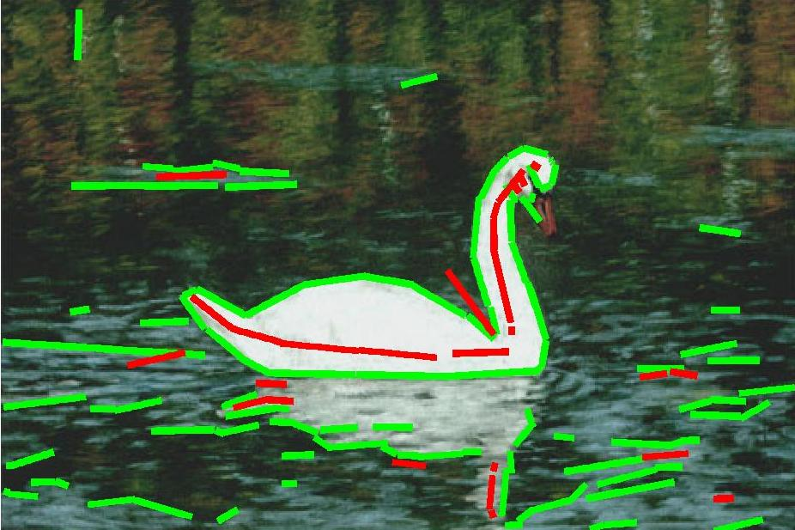

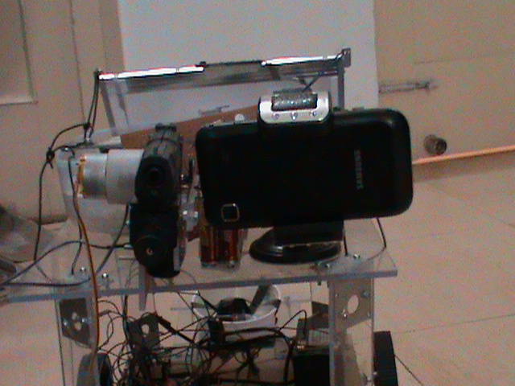

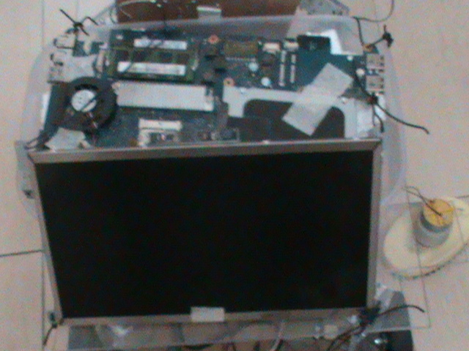  
Robot front and rear view